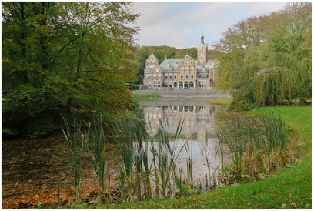

**ELPHA GENERAL ASSEMBLY, THE NETHERLANDS**

**SANTPOORT- NOORD, 18th – 20th JUNE 2025**

**REGISTRATION FORM**

Please complete one form per delegate and make a copy if you register more delegates. Please write in BLOCK LETTERS or type and return to: Jan Buitenhuis e-mail: [jbuitenhuis@aviagen.com](mailto:jbuitenhuis@aviagen.com)

Family name: First name:

Title/Position:

Organization/company: Address:

City: ZIP: Country:

VAT Number: e-mail: @

Phone:

# Accompanying Person

Family name: First name:

# Dietary requirements

Delegate: Accompanying Person:

|  |  |  |  |
| --- | --- | --- | --- |
| **Registration fees** | (€/Person) | **Number of Person** | **Amount**  (€) |
| ELPHA Member | €600 |  |  |
| Accompanying Person | €550 |  |  |

**Please tick if attending**

|  |  |  |  |  |  |
| --- | --- | --- | --- | --- | --- |
| Welcome lunch 18th |  | Tour 19th |  | Gala diner 19th |  |

|  |  |  |  |
| --- | --- | --- | --- |
| **Reservation Rooms** | (€/night) | **Number of Person** | Request |
| Tuesday June 17th 2025 | €200 |  |  |
| Wednesday June 18th 2025 | €200 |  |  |
| Thursday June 19th 2025 | €200 |  |  |

Date: Signature: